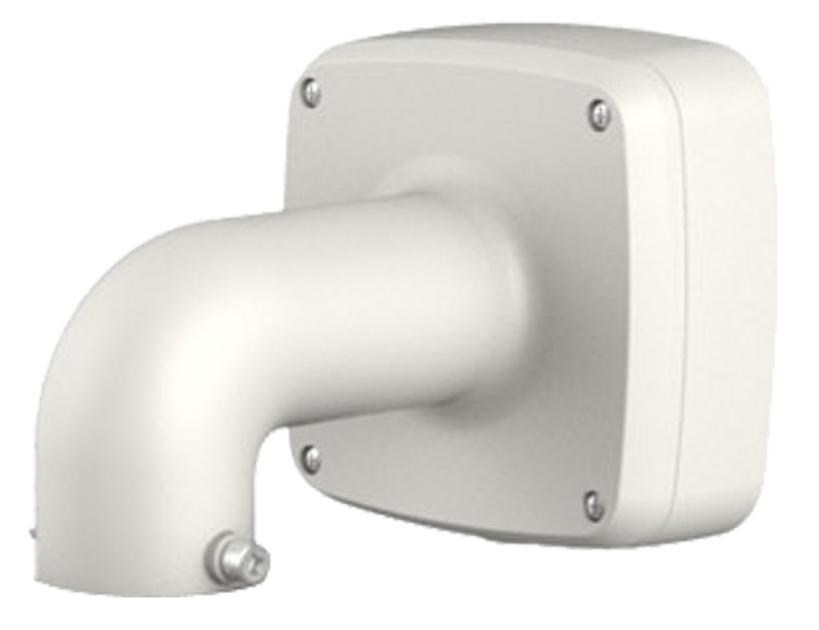
整潔和易收納設計
鋁合金材質
IP66防水型壁掛式接線盒
壁掛防水盒支架
◆
◆
◆
型號: PFB302S2
型號 | PFB302S2
材質 | 鋁合金
尺寸(WxHxD) | 134.0 mm x 133.5 mm x 187.5 mm (5.28”x 5.25”x 7.38”)
管螺紋 | G3/4”
重量 | 0.7 kg (1.54 lb)
承重 | 4.0 kg (8.82 lb)
顏色 | 白色
防護等級 | IP66
工作環境 | -40ºC~+60ºC(-40℉~+140℉), 0~90% RH

(單位：mm[inch])

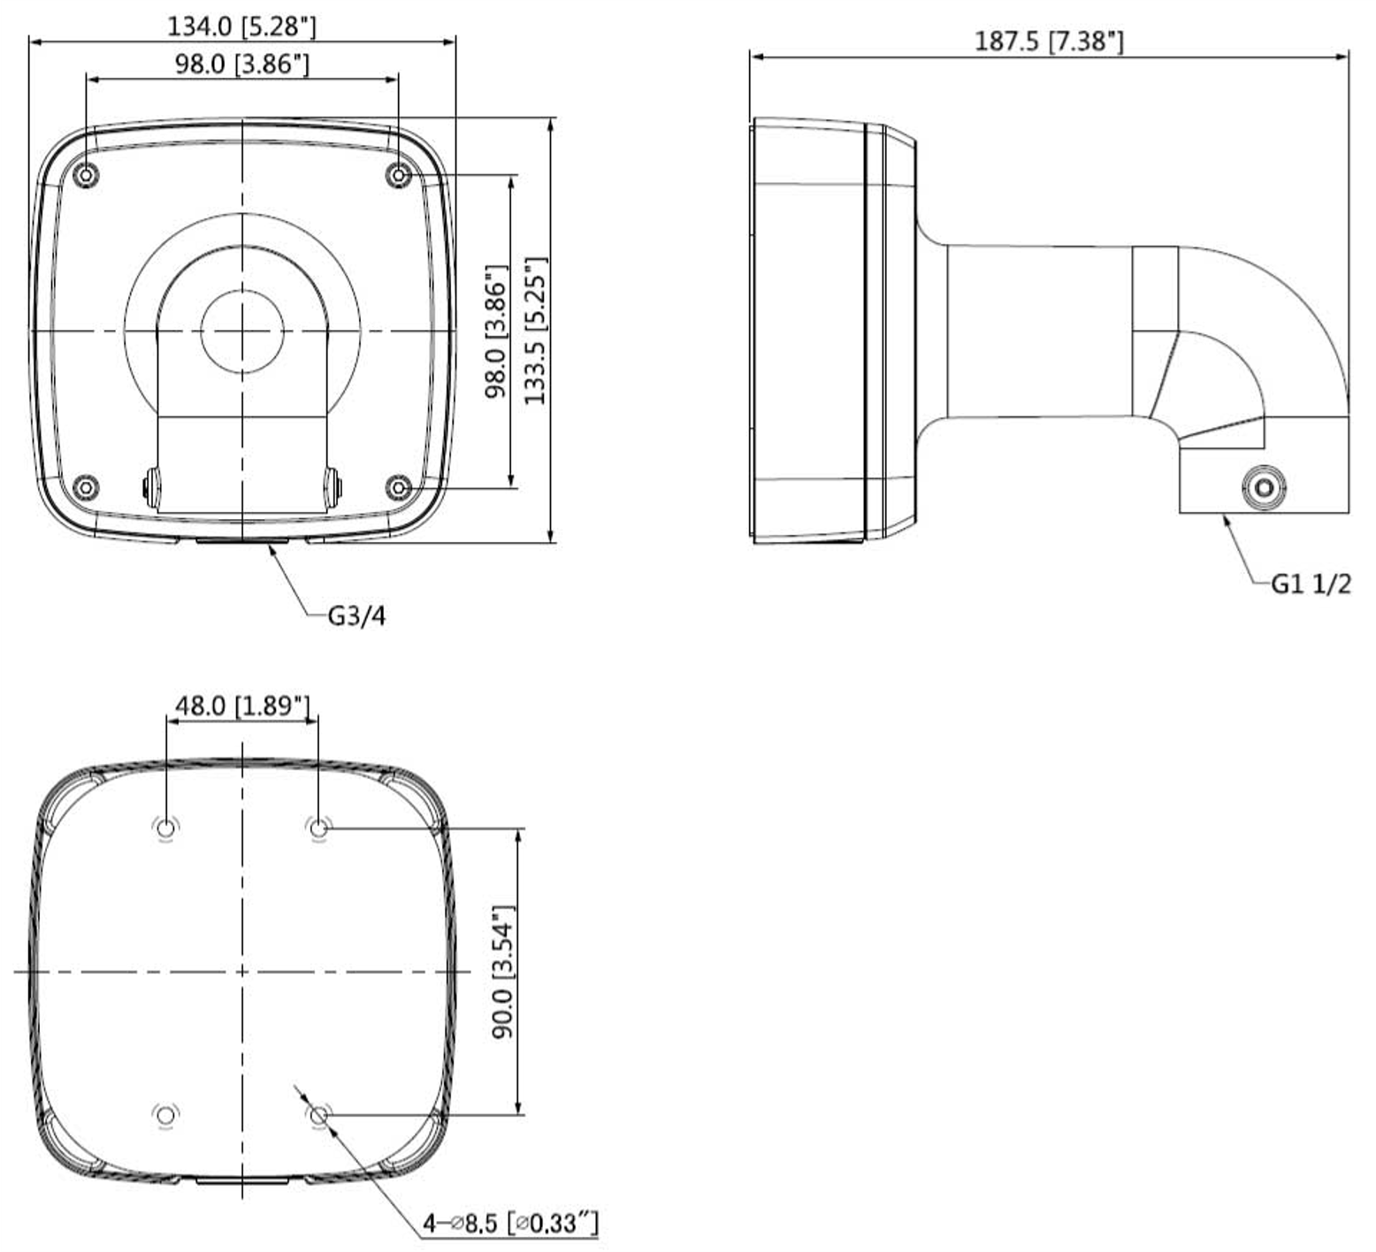

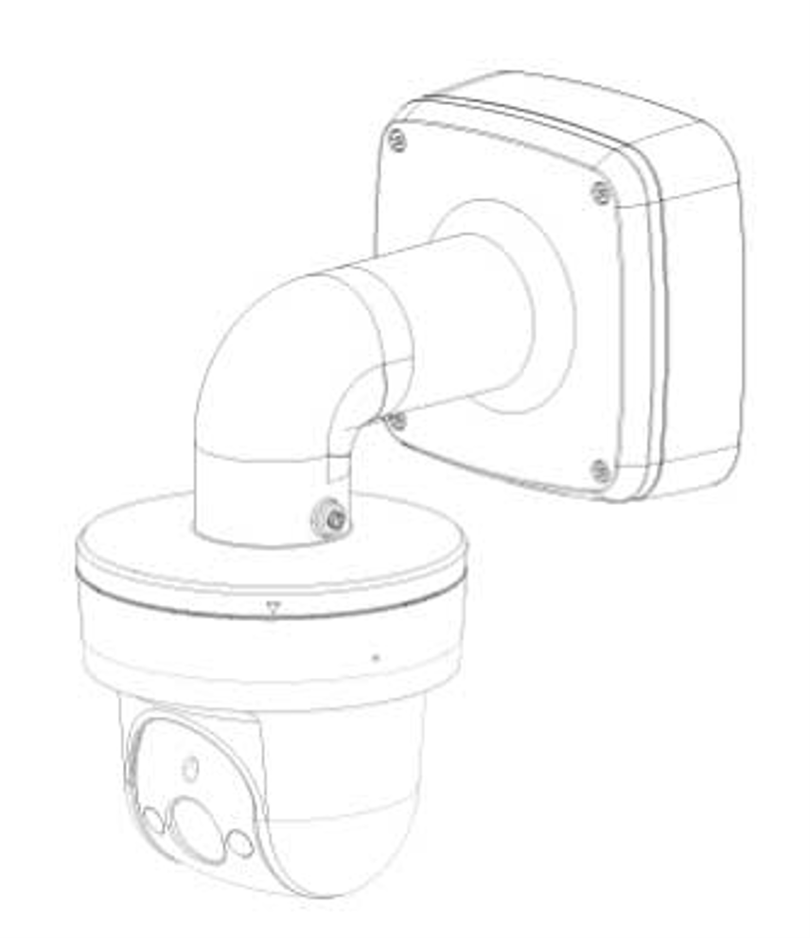
※型錄規格若與實機不符，以實機為準。
※本公司保留修改此規格之權利，修改後不另行通知，實際內容請隨時來電洽詢。

