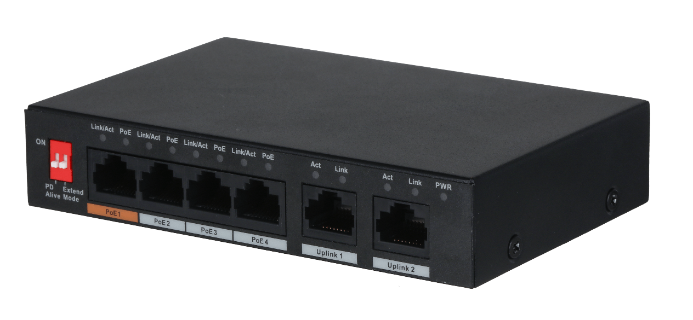
–
桌上型交換器
型號: PFS3006-4ET-60
6埠 10/100Mbps 非網管型
(含 4埠 PoE)
Layer 2 商用交換機
支援 IEEE802.3、IEEE802.3u、IEEE802.3ab和IEEE802.3x標準
MDI/MDIX 自適應控制
RJ-45接口，支援10/100Mbps自適應控制，並確認802.3at 和 802.3af 供電標準
連接埠1，支援Hi-PoE 60W供電
250m PoE供電
壁掛式和機械防盜
53V直流供電
支援PoE看門狗( Watchdog )
◆
◆
◆
◆
◆
◆
◆
◆
◆

型號 | PFS3006-4ET-60
乙太網路接口 | 4
光纖接口 | 0
乙太網路接口速率 | 100 Mbps
商用卡槽 | Port 1-4 : 4 × RJ-45 10/100 M (PoE)  Port 5-6 : 2 × RJ-45 10/100 M (uplink)
電源 | 53V DC
輸入電壓 | 100–240V~,50/60Hz,1.5A
工作溫度 | -10°C to +55°C (+14°F to +131°F)
工作濕度 | 5%–95%
儲存溫度 | -20°C to +70°C (-4°F to +158°F)
儲存濕度 | 5% - 95%
電力消耗 | Idling: 1.5W / Full load: 60W
 | 性能
交換能力 | 1.80 Gbps
封包轉發率 | 0.89 Mpps
封包緩衝 | 1 Mbit
MAC Table Size | 2K
通訊標準 | IEEE802.3, IEEE802.3u, IEEE802.3x
光圈類型 | 固定光圈
最短對焦距離 | 0.8m~0.8m
 | PoE
PoE 標準 | IEEE802.3af/IEEE802.3at/Hi-PoE
PoE 電源 | 60W
PoE 功耗管理 | Yes
PoE Pin分配 | PoE/Hi-PoE: 1, 2, 4, 5 (V+), 3, 6, 7, 8 (V-)
遠距模式 | 250 m @10 Mbps
 | 一般
ESD 靜電釋放 | Air discharge: 8kV  Contact discharge: 6kV
防雷 | Common mode: 2kV  Differential mode: 1kV
淨重 | 0.3 kg (0.66 lb)
總重量 | 0.9 kg (1.98 lb)
產品尺寸 | 130 mm × 85 mm × 26 mm (5.12" × 3.35" × 1.02")
包裝尺寸 | 267 mm × 239 mm × 77 mm (10.51" × 9.41" × 3.03")

※型錄規格若與實機不符，以實機為準。
※本公司保留修改此規格之權利，修改後不另行通知，實際內容請隨時來電洽詢。

