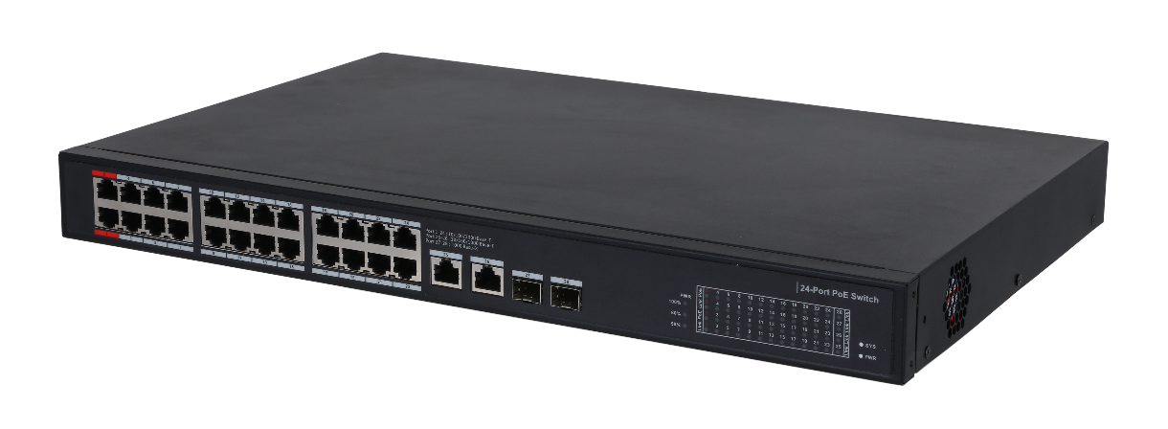
–
◆
◆
◆
◆
◆
◆
支援 IEEE802.3bt
紅色接口支援 BT 90W
全giga Ports
傳動平穩
寬溫範圍：–10°C 至 55°C（14°F 至 131°F）
即插即用
型號: PFS3228-24GT-360
交換器
非網管型 智能PoE
型號 | PFS3228-24GT-360
Layer | Layer 2
管理 | No
交換能力 | 52 Gbps
封包轉發率 | 38.688 Mpps
封包緩衝儲存 | 4 Mbit
MAC Table Size | 8K
通訊標準 | IEEE802.3, IEEE802.3u, IEEE802.3x, IEEE802.3ab, IEEE802.3z
 | 硬體
標準電源 | Yes
PoE | Yes
乙太網路接口 | 24
光纖接口 | 2
乙太網路接口速率 | 1 Gbps
光纖接口速率 | 1 Gbps
商用卡槽 | Port 1–24: 24 × RJ45 10/100/1000 M (PoE)  Port 25–26: 2 × RJ45 10/100/1000 M (uplink)  Port 27–28: 2 × SFP 1000 M (uplink)
電源 | 100V AC–240V AC
工作溫度 | –10°C to 55°C (14°F to 131°F)
工作濕度 | 10%–90%
儲存濕度 | 5%–95%
電力消耗 | Idling: 8W / Full load: 360W
 | PoE
PoE 標準 | IEEE802.3af, IEEE802.3at, Hi-PoE, IEEE802.3bt
PoE 預算 | Port 1–2≤90W, Port 3–24≤30W, total≤360W
PoE Pin分配 | PoE/Hi-PoE: 1, 2, 4, 5 (V+), 3, 6, 7, 8 (V-)
 | 一般
ESD 靜電釋放 | Air discharge: 8kV  Contact discharge: 6kV
防雷 | Common mode: 4kV  Differential mode: 2kV
產品尺寸 | 440 mm × 300 mm × 44 mm (17.32" × 11.81" × 1.73")
包裝尺寸 | 527 mm × 412 mm × 110 mm (20.75" × 16.22" × 4.33")

※型錄規格若與實機不符，以實機為準。
※本公司保留修改此規格之權利，修改後不另行通知，實際內容請隨時來電洽詢。

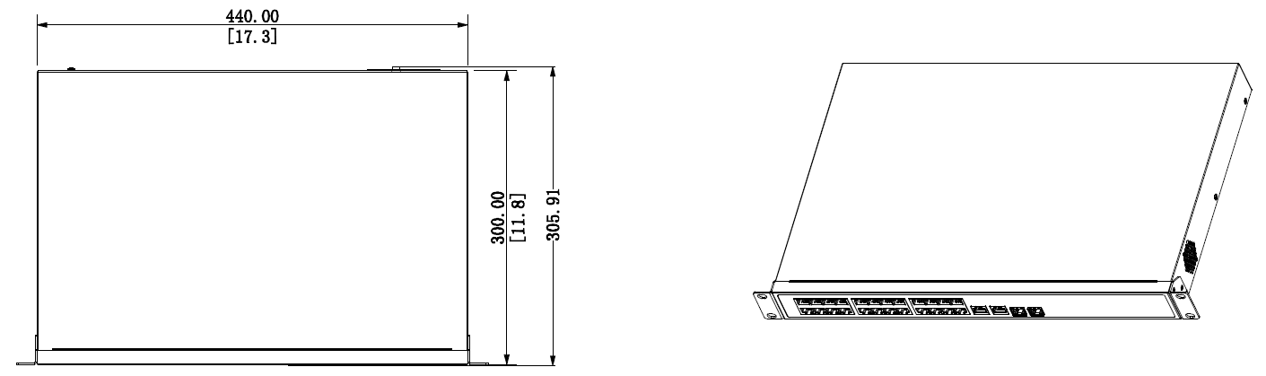
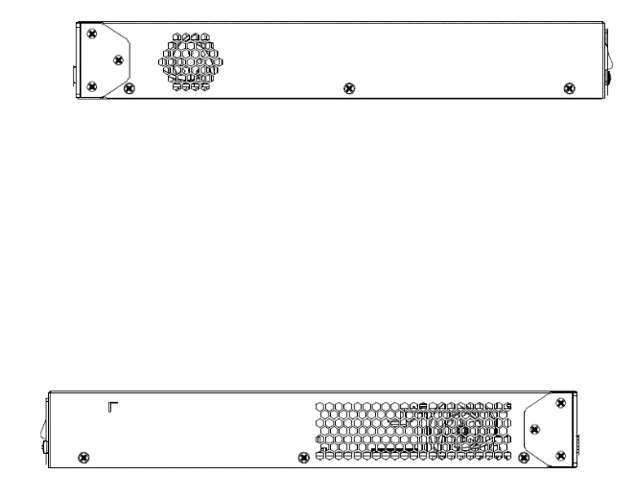
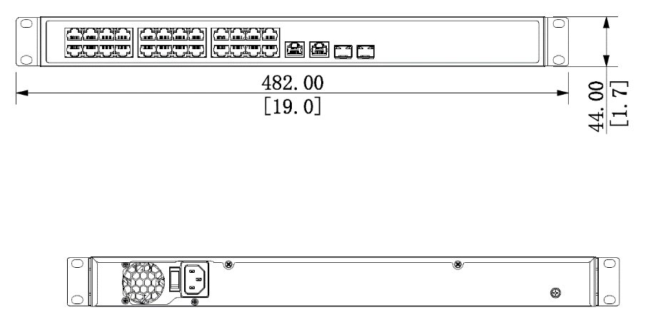
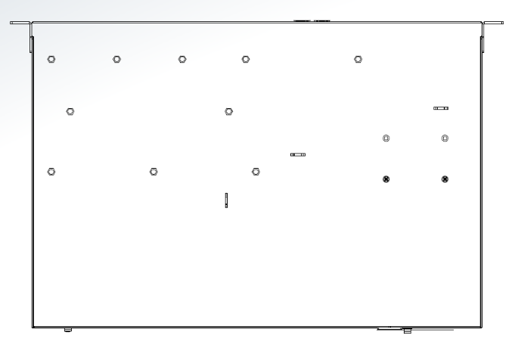
(尺寸單位：mm)

